Solution Design Document

ODS TG1 Balance Sheet Automation

**Process Name** : ODS TG1 Balance Sheet Automation

**Prepared by** : Novigo Solutions

**Date Prepared** : 18-11-2019

**Last Updated** :

**Version** : 1.0

TABLE OF CONTENTS

1 DOCUMENT HISTORY 3

2 DEVELOPERS 3

3 GLOSSARY OF TERMS 3

4 DATABASE 3

5 SQL QUERIES 3

6 DETAILED PROCESS FLOW 4

7 FLOW CHART 5

8 EXCEPTIONS 6

9 PROCESS CONFIGURATION 6

# DOCUMENT HISTORY

|  |  |  |  |
| --- | --- | --- | --- |
| **Version** | **Description** | **Date** | **Author** |
| 1.0 | Initial Draft | 18-11-2019 | Shishir |

# DEVELOPERS

|  |  |
| --- | --- |
| **Name** | **Package Version** |
| Shishir |  |

# GLOSSARY OF TERMS

The following table includes definitions for any abbreviations or notations that are used in the document:

|  |  |
| --- | --- |
| **Term** | **Definition** |
| RPA | Robotic Process Automation |

# DATABASE

Three tables are created in the Database:-

1. ODS_TG1_BalanceSheet

FIELDS:

* ODS_Id (primary Key)
* ODS_FileName
* ODS_PlacedInFolder
* ODS_Exception

# SQL QUERIES

1) Insert query is used to keep track of the downloaded file in RPA Staging Table

**“**INSERT INTO ODS_TG1_BalanceSheet (ODS_FileName, ODS_PlacedInFolder) VALUES ('"+out_FullFileName+"','Success')**”**

# DETAILED PROCESS FLOW

Step 1 - Robot will login to TG1 VPN with valid credentials.

Step 2 - After the VPN is successfully connected, Robot will login to SAP system with valid credentials.

Step 3 - Once the Login to the SAP system is complete Robot will enter the TCode (ZCOJ101).

Step 4 - The Monthly Statement (Account/Cost Center Selection) Form will be Opened up. Robot will fill up the following SAP Fields and Execute:

* Fiscal Year
* Period From
* Period To
* Cost Center

Step 5 - The Monthly Statement AC Report will be generated.

Step 6 – Robot will Read the Variation in Cost Center from the input file

Step 7 – Robot will check if the Variation is present in SAP and process either of the below,

* If Variation is present, then Robot will select it .
* If Variation is not present, then Robot will skip that particular variation.

Step 8 – Once the Variation is selected DAT file and XLSM file is generated and stored in destination folder.

Step 9 – Process is repeated for all the variation present in the input file.

Step 10 – Robot will disconnect from SAP system and TG1 VPN

# FLOW CHART

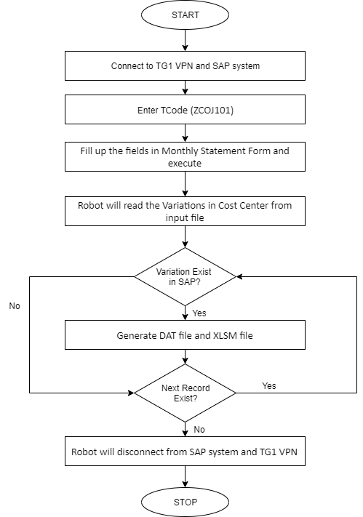

# EXCEPTIONS

1. **Application Exception**

|  |  |  |
| --- | --- | --- |
| **SL NO** | **EXCEPTION** | **RESOLVE** |
| 1 | TG1 VPN connectivity issues | Connection has to be stable |
| 2 | SAP connectivity issues | Connection has to be stable |
| 3 | Entered Invalid Data | Monthly Statement form do not contain data for given input |

1. **Business Exception**

|  |  |  |
| --- | --- | --- |
| **SL NO** | **FIELD** | **EXCEPTION** |
| 1 | Invalid Variation | File Not found in SAP |

# PROCESS CONFIGURATION

1 - “Config.xlsx” Contains all the Config data like SAPTCode, Destination Folder Path etc. used in the Process.